Assignment 2

Plan an activity for each domain of development in detail for age 3-4 years

There are 4 domains for an early childhood development. These 4 domains are as follows:

1. Cognitive ( reasoning and logical thinking)
2. Language ( oral and written skills)
3. Physical ( use of big and small muscles)
4. Socio-emotional ( manage emotions and interaction with others)

**Cognitive (Activities to support intellectual development) for age 3-4 years**

Hosting a tea party where the child takes the lead. The child taking the lead will dwell into various thought of how he/she wants to organize their party. Having pictures of tea parties around them will make them follow the same and be creative in their own way of organizing one. Planning a pretend tea party will make a child act in certain order (planning, recall and set up) which will make them find ways in accomplishing goal in the picture ( problem solving)

**Material needed** : Plastic utensils , tea pot , tea cups , table cloth , props to make it fancy and let the child imagine and think what else they want to add.

**Execution :**

* Allow child to take the lead and have them set up the table themselves.
* Have pictures around them to think and follow the pattern or organizing one.
* Make a list or image list and have the child go around the area to grab things and help child mark it down or cross it off.
* After finding all the elements or things , help child set it up and enjoy tea party with them.

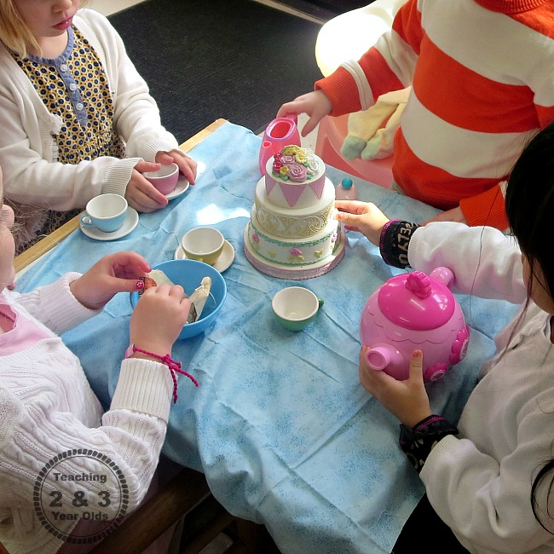

2) **Language development** for age 4 years or above

Language development is an ongoing process in child development. Often kids mimic their elders around and try to say words which do sometimes not make sense but they learn word pronunciation, phonetics and word formation. One such activity for them is doing a puppet play, during this play we can have kids repeat after us like the same in the cartoon called Mickey mouse play house .

**Material needed** – animal stuffed toys , if not a sock and buttons, glue , marker , cardboard to make the stage and a cloth to make curtain , some fanny decorations to decorate the stage to catch kids attention.

**Execution**

* Make a platform or a stage using the cardboard and make it colorful and hand draw some tress , grass and make the outside of the stage as a jungle
* From behind the stage using our hands, an educator with start the puppet show with using various soft animal toys and making sound and having kids repeat after for instance

Cow says ‘MOOOOO’

Frog says ‘Ribbit ribbit’

Lion says ‘Roar’

Dog says’ Wooff Wooof ‘

Have the kids sometime to respond to the sounds and then it will pick up a rhythm of kids repeating It after. This will inculcate habit of word formation and help them increase complexity in their language speaking ability. These small funny words will make vocal cords train for complex words in future.

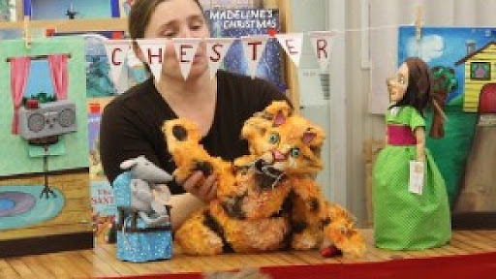

3) **Physical development (improving fine and gross motor skills)** for age 3-4 years

Physical development often includes training of fine motor skills and gross motor skills which is nothing but small and large muscles respectively. Lot of activities we do involve our muscles such as finger muscles, hands, arms , legs and over all body). One such activity is play dough activity

Create things with play dough which involves fingers ,palm and hand muscles. Outcome of this will help train their fine and gross motor skills by actions like rolling , squishing, patting , grasping and squeezing . this activity will help kids increase their skill for cutting paper and grabbing a pencil to enhance pincer grasp.

**Material needed** : store bought play dough ( chemical free ) and napkins, ice cream stick to use as cutter , various shapes or moulds , collage of pictures for kids to follow , table and baby liner to cover their clothes from getting dirty.

**Execution**:

* Give all the kids play dough of different colors. Place pictures of different items made out of the dough for them to copy or make something similar out of it.
* Have them use all the moulds and shapes to cast their dough into whats on the pictures.
* Not all kids follow the same, it they are creative have them make something of their own and appreciate the result.
* Make sure to enjoy the activity with them
* Add things like glitter , pearls , stars to have them use it on their play dough which will enhance their pincer grasp while picking them.

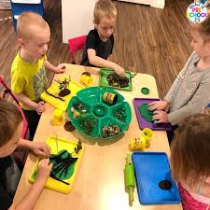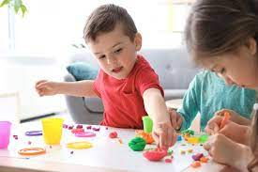

1. **Socio- emotional skills ( manage emotion and interaction with others**) for age 4 years

This is the most relevant skill that kids need to learn while they grow up as this helps them flourish in the market or in the outside world. Social and emotional skills are pivotal in life as they help the other skills develop faster if the child is socially and mentally stable. An appropriate environment for a child social and emotional development which can be created in pre schools by pretend play activities with daily life examples and one such example is grocery shopping. This activity will inculcate habit of negotiating and also make them interact with people by saying Excuse me , thank you , hello , see you again .

**Pretend play grocery shopping**

Material needed : plastic vegetable and fruits , a fake scanner or remote , table , stars and beads used as money or coins , shopping play cart , shopping bags, cash register ( toy setup or crafted), charts and some colors to decorate and draw veggies and fruits.

**Execution**

* Set up a table and put a table cloth on it. Put the cash register on it and scanner near the register. Have one of the kid act as a cashier.
* Have the table decorated as a cash counter with paper charts with drawings of veggies and fruits and their price.
* Have each kid perform picking up the vegetables they like and run to the cash and perform activity by buying veggies with stars and beads. Like for eg. one cucumber is for 2 stars and one apple for 4 beads which will be on the chart.
* Each kid performs this one by one so they will also learn skills like patience and turn taking helps them learn about civic sense
* Make sure to enjoy with kids and also help them in the activity as well.

