======================Assignment -5 ============================
Introducing literacy in early childhood education is crucial for laying a strong foundation for a child’s academic and personal development.
LSRW stands for Listening, Speaking, Reading, and Writing. It represents the four basic language skills that are essential for effective communication in any language.Some approaches of introducing literacy is as follows:
Reading to children : exposes them to language, vocabulary, and various literary concepts. It also develops listening skills.
Facilitators can read age-appropriate books to children regularly, discussing the story, characters, and illustrations to improve comprehension.
Phonics awareness:
Phonemic awareness involves recognizing and joining individual sounds in words,
Storytelling :
Encourages children to express their thoughts and ideas.
Literacy is a continuous and progressive process that starts from birth and evolves as children grow and develop. Literacy learning happens from the time the baby is my womb
Here are some activity with description & material required across different range of children
- O-2 years
- 2-3 years
- 3-4 years
- 4-5 years
- 5-6 years

0-2 years::
1.Picture card naming:
Description : Create a set of picture cards with simple and familiar objects such as animals, fruits, and toys.
Materials required
Picture cards with small objects
Learning Objectives
- Develop visual recognition skills.
- Introduce vocabulary and object naming.
2.Touch and Feel Book:
Create a touch and feel book using different textures like soft fur, smooth silk, and rough sandpaper. Introduce the book to the child, guiding their hands over each texture while naming it.
Materials Required:
- Fabric scraps (fur, silk, sandpaper)
- Thick cardboard or foam sheets for book pages
- Glue
Learning Objectives:
- Develop sensory awareness through touch.
- Introduce descriptive vocabulary.
- Exploration along with curiosity.
2-3 years ::
In this age group the basic sounds are already introduced to the child along with the song and story for each the basic sounds to start with s,a,t,i,p,n,c,k,e,h,r,m,d
Activity :
- Hopscotch :
Draw a hopscotch grid with phonic letters instead of numbers. Call out a sound, and the child has to hop to that letter.
Materials Required:
Chalk
Learning Objectives:
- Recognize and identify alphabet letters.
- Enhance gross motor skills through hopping and movement.
- Develop letter-name recognition and phonemic awareness.
- Treasure Hunt

Description:
Hide foam or magnetic letters around a safe play area. Give the child a small basket or bag to collect the letters and identify them.

Materials Required:
- Foam or magnetic alphabet letters
- Small basket or bag for collecting
- Play area or room
Learning Objectives:
- Recognize and identify alphabet letters.
- Enhance gross motor skills through movement.
- Develop letter-name recognition and phonemic awareness.

3-4 years

- CVC coins
Place plastic coins on the sound and ask the child to read the sound together
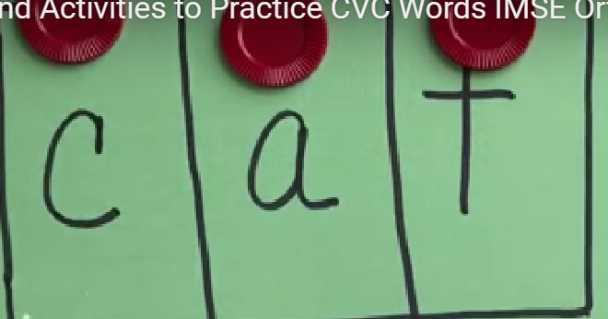

Materials required:
Paper cut out of the word
Plastic coins
4-5 years
1.Sight Word Bingo
Description:
Create bingo cards with sight words. Call out the words and have the child mark them on their card.
Materials Required:
- Bingo cards with sight words
- Markers or counters
- Calling cards with sight words
Learning Objectives:
- Recognize and read common sight words.
- Develop word recognition and reading fluency.
- Enhance listening and attention skills.
2. Sight Word Memory Match
Description:
Create pairs of cards with common sight words. Place the cards face down and have the child flip them over to find matching pairs.
Materials Required:
- Cards with common sight words
- Cardboard or paper for making cards
Learning Objectives:
- Recognize and read common sight words.
- Enhance memory and concentration.
- Improve word recognition and reading fluency.
5-6 years:
- Story Chain
Description:
Start a simple story with a sentence, then have the child add the next sentence and so on, creating a collaborative story chain.
Materials Required:
- Story starter sentence cards
- Blank cards for the child to add their sentences
- Story chain board or wall space to display the story
Learning Objectives:
- Develop comprehension and narrative skills.
- Enhance storytelling and sentence construction.
- Improve listening, speaking, and collaborative skills.
2.Musical circle
Description :
When the music stops kid have to go and stand in the ring of which word the facilitator calls out
Material required:
Hoopla ring, Paper cut outs of the words to be placed
Learning Objective:
- Active listening
- Recognise tricky words

