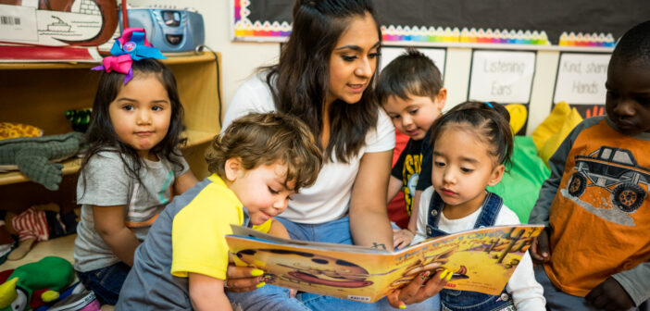
EARLY CHILDHOOD EDUCATION

ECE plays an important role in child life as 80% of the brain development happens before the age of 8yrs and remaining 20% happens after 8yrs.It provides a strong and quality foundation to the child. For the betterment of India, we as educators should make all the young parents understand the importance of ECE, and encourage them to send their kids to preschool since it helps in the holistic development of the child. All the parents should be educated about the 4 domains -language development, cognitive development, physical development (fine motor skills and gross motor skills) and social emotional development.
Through Anganwadis and playschool children can learn many things and have lot of exposure also. Many concepts like numeracy, literacy, rhymes, stories and many more are introduced to them. They are well prepared for higher schooling. Children becomes creative and develops reasoning and logical thinking through the brain churning activities done in the school. Activities help in developing eye hand coordination and sensorial skill also. A proper routine is developed in the child life which encourages them to become independent. Thus, for the betterment of India, ECE should be encouraged.

