**Importance of Health and Hygiene**

Health and hygiene are the foundation of a child’s growth, learning, and overall development. In India, where millions of children face nutritional and sanitation challenges, ensuring healthy practices is more important than ever.

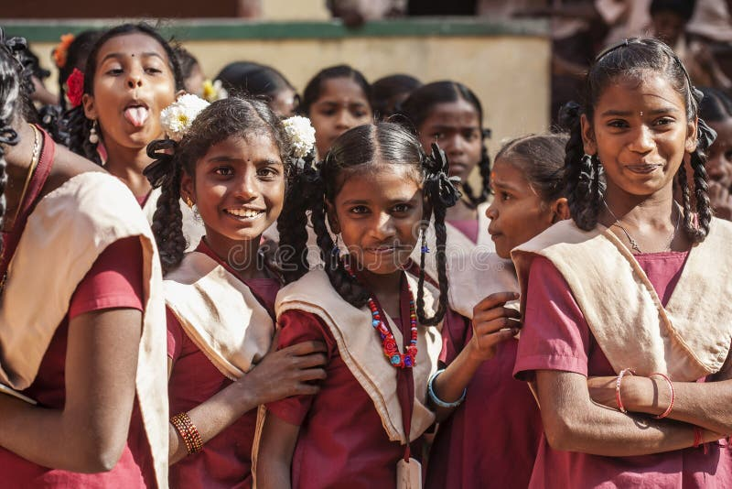

According to NFHS-5 (2019-21), around 35.5% of children under five are stunted, 19.3% are wasted, and 33.4% are underweight. UNICEF further reports that unsafe sanitation causes nearly 100,000 diarrhoeal deaths in Indian children under five every year. Lack of WASH (Water, Sanitation, and Hygiene) facilities continues to be a barrier: 22% of schools still lack toilets for girls, and over 58% of preschools had no toilet facilities. In 2018, nearly 47% of Indians did not wash hands with soap after defecation, directly impacting children’s health.

Campaigns like the “**Stop Diarrhoea Campaign 2025**”, which targets over 50 lakh children in Haryana and Andhra Pradesh, show that community health initiatives can make a huge difference.

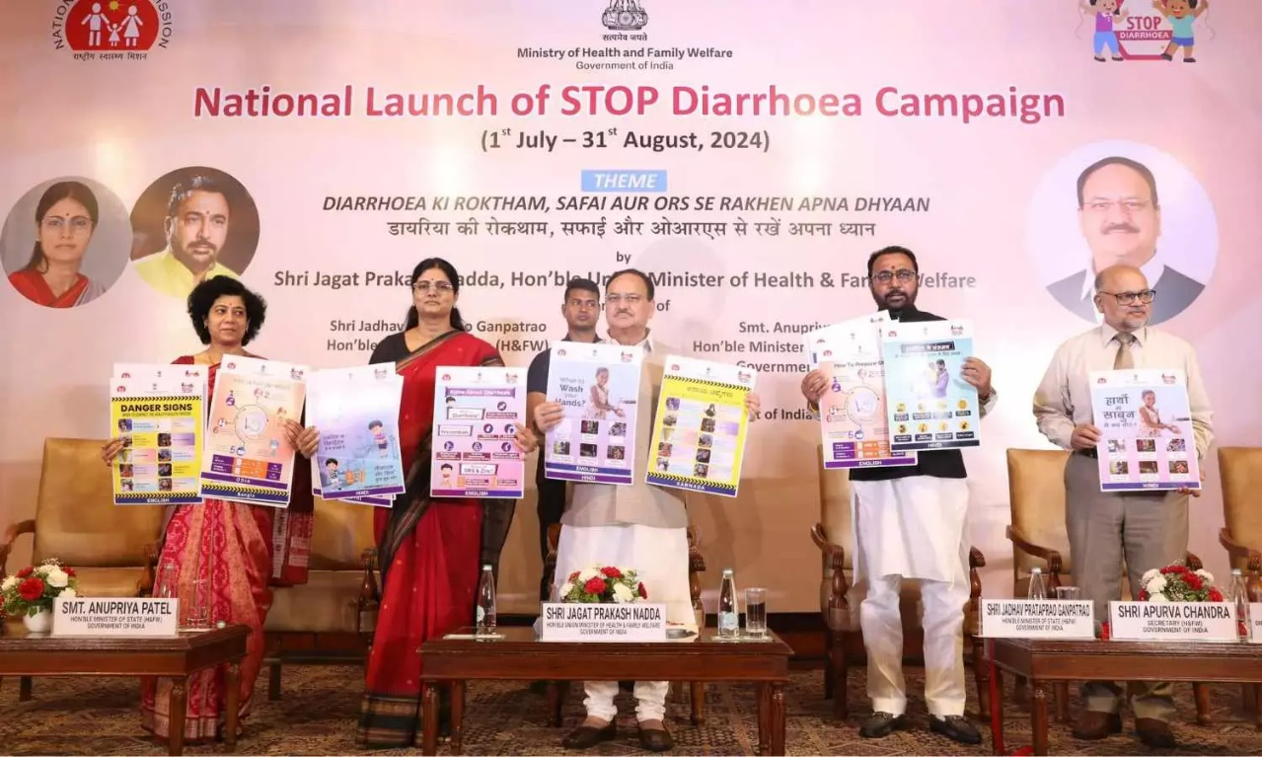

<https://nhm.gov.in/index4.php?lang=1&level=0&linkid=516&lid=820>

**Issues Faced by Indian School Girls During Menstrual Periods**

Menstruation is a natural process, but for many Indian school girls it becomes a challenge that affects their education. According to a UNICEF report, nearly **50% of girls in India are unaware of menstruation before their first period**. This lack of awareness, along with taboos and stigma, makes them feel anxious and unprepared.

Infrastructure is another major issue. Surveys show that **only about 55% of schools in India have separate functional toilets for girls**. Without clean toilets, running water, or proper disposal systems, many students skip school during their periods. Studies suggest that girls miss **up to 5 school days each month**, and around **23% drop out of school entirely once they start menstruating**.

Period poverty adds to the problem—many girls cannot afford sanitary pads, and nearly **71% rely on old cloth or unsafe alternatives**, increasing the risk of infections.

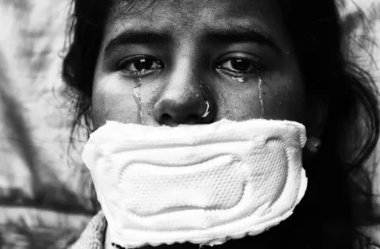 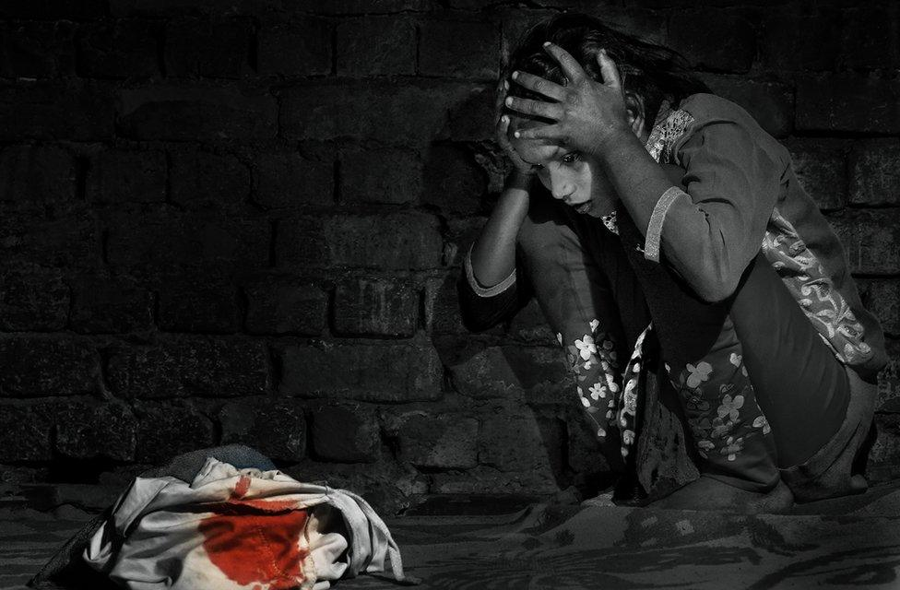

<https://www.bbc.com/news/world-asia-india-52830427>

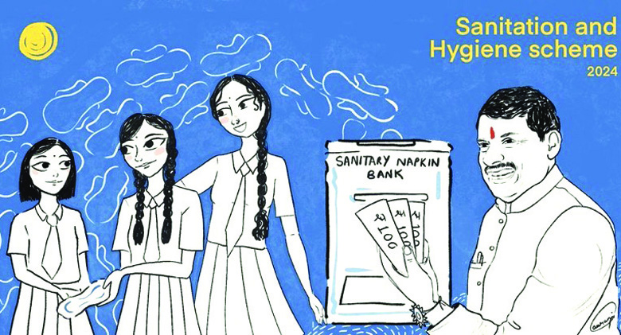

Government schemes like the **Menstrual Hygiene Scheme (2011)** and free sanitary pad distribution in states like Tamil Nadu, Kerala, and Delhi are improving the situation. However, continued awareness, better facilities, and breaking taboos are essential to ensure girls manage menstruation with dignity and continue their education without barriers.

<https://nhm.gov.in/index1.php?lang=1&level=3&sublinkid=1021&lid=391>

A healthy life goes beyond just avoiding illness. It includes eating a balanced diet rich in fruits, vegetables, proteins, and whole grains to fight malnutrition, which still affects over one-third of Indian children. Regular physical activity helps strengthen immunity, prevent obesity, and support brain development.

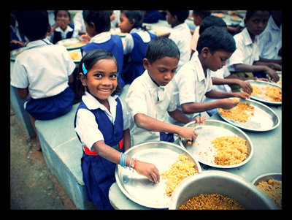 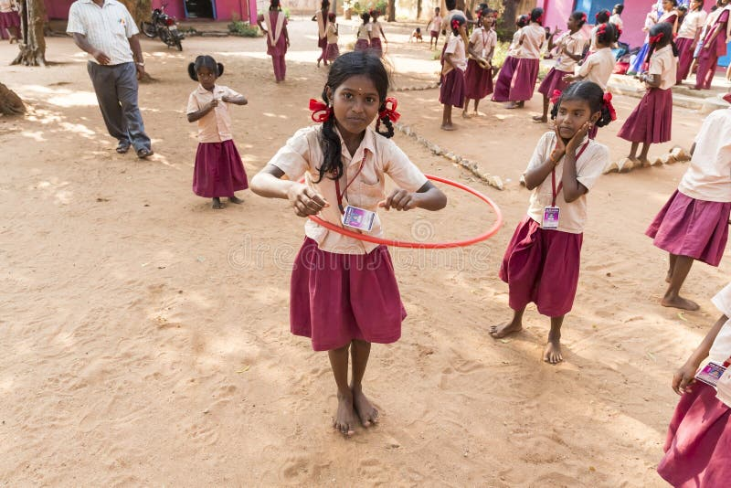

Good hygiene habits—such as handwashing, brushing teeth twice daily, and safe drinking water—protect children from infectious diseases. Adequate sleep and mental well-being are also essential for growth and learning

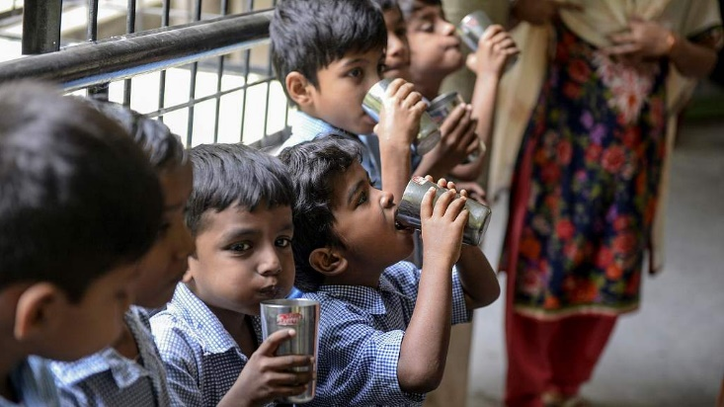 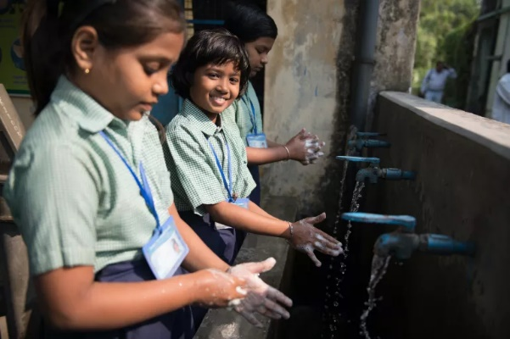

In conclusion, children’s health and hygiene are not just medical issues but building blocks of a healthy life, shaping stronger bodies, sharper minds, and a brighter future for the nation.

