**Promotion of sanitation and hygiene in a rural area**

**Assignment-6**

### **Introduction:**

One of the world’s most urgent issues is lack of safe water, sanitation and hygiene. Water-related improvements are crucial to meet the development goals, reduce child mortality, and improve health in a sustainable way. The absence of WASH in schools is responsible for 20% of total deaths and disability adjusted life years (DALYs) in children. Over 440 million schools days are missed annually due to water, sanitation and hygiene related diseases. Though there are emerging vaccines for rotavirus and cholera still WASH remains critical in the prevention of diarrheal diseases, soil transmitted helminthes infections and acute respiratory diseases. Objective of the study was to study the implementation and functionality of WASH in schools.

### **Toilet Issues Facing in Rural Government Schools**

Access to safe and hygienic sanitation is a basic necessity for children in schools. However, in many rural government schools across India, the condition of toilets remains a major challenge. Lack of proper sanitation not only affects the health of students but also impacts their education, attendance, and dignity.

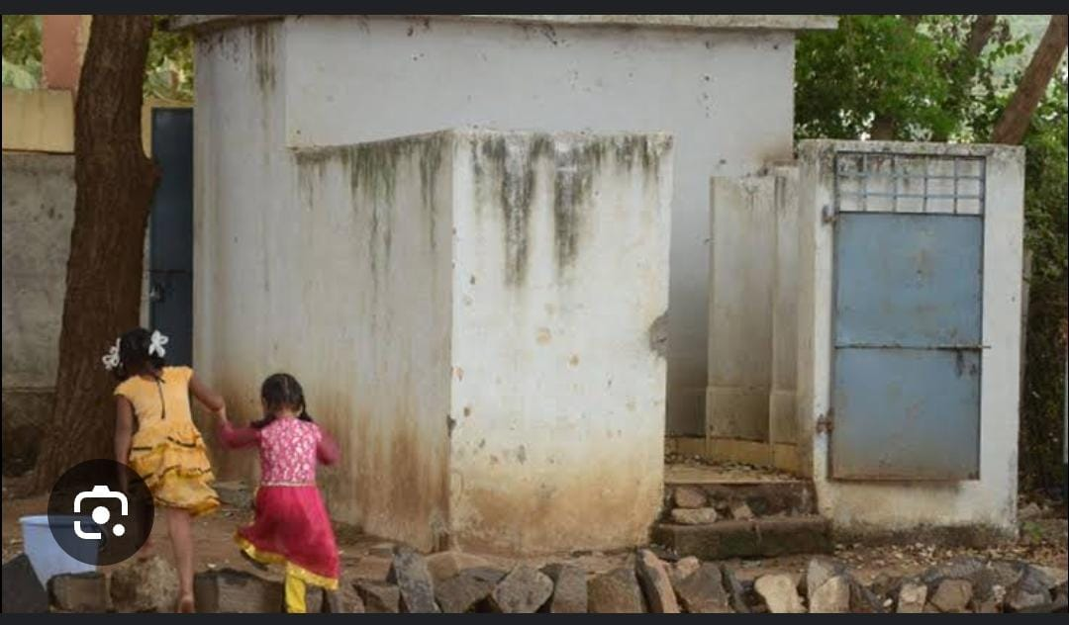

#### 1. **Insufficient Toilet Facilities**

Most rural government schools either have very few toilets compared to the number of students, or in some cases, no functional toilets at all. This overcrowding leads to unhygienic conditions and discourages children, especially girls, from using them.

#### 2. **Poor Maintenance and Hygiene**

Even where toilets exist, they are often poorly maintained due to lack of regular cleaning, shortage of water supply, and absence of dustbins. Dirty and smelly toilets create an environment where children prefer to avoid using them, leading to health risks.

#### 3. **Gender Inequality in Facilities**

Separate toilets for boys and girls are still missing in several rural schools. This lack of privacy particularly affects adolescent girls, many of whom skip school during menstruation or drop out altogether due to absence of menstrual hygiene facilities.

#### 4. **Water Supply and Infrastructure Issues**

Inadequate water supply makes it impossible to maintain cleanliness. Many toilets do not have running water, taps, or proper drainage systems, which makes them unhygienic and unsafe.

#### 5. **Health Concerns**

Poor toilet conditions contribute to the spread of infections, worms, diarrhea, and urinary tract infections among children. This directly impacts attendance and overall health, lowering their ability to focus on studies.

*6.* ***Impact on Education***

When children avoid toilets or stay absent from school due to sanitation issues, their learning suffers. Girls are the most affected, as lack of safe and private toilets becomes a barrier to their continued education.

#### 7. **Need for Sustainable Solutions**

To address these issues, there is a need for:

* Construction of adequate and separate toilets for boys and girls.
* Regular cleaning and maintenance with the help of local committees.
* Ensuring constant water supply and proper waste management.
* Awareness programs for students about hygiene and sanitation.

**Building and maintaining toilets is a major endeavor for Infosys Foundation. Sudha Murty shares her experiences with rural sanitation.**

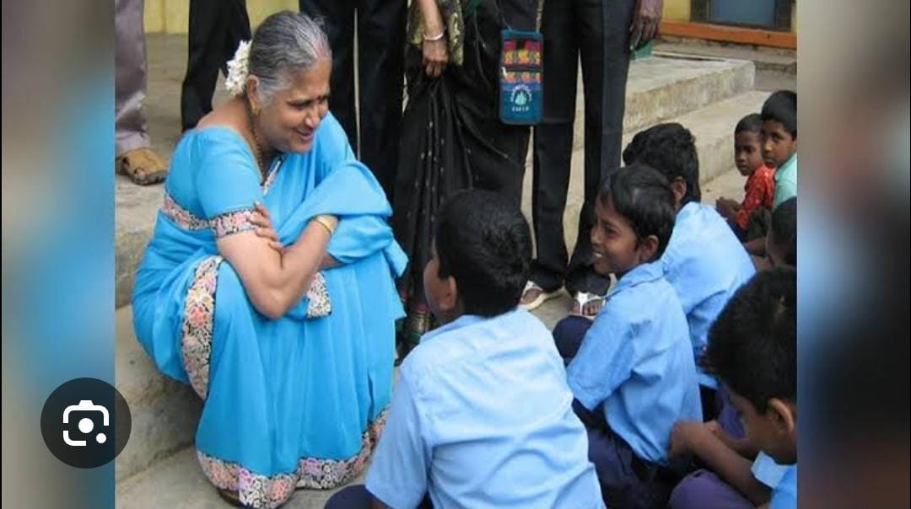

Her first exposure to sanitation issues occurred when she got admission into an engineering college. They probably didn’t want to admit her and informed that there was no ladies toilet in the college. She was adamant and pursued her studies in engineering in that very college. She would walk to her house which was 2 kilometers away from the college to use the toilet. While it definitely was a difficult situation, and somehow, she managed it, it was early eye opener to the sanitation situation in India.  
  
After, at Infosys Foundation, started working on sanitation about 20 years back. She was driving through a village in north Karnataka, where she saw women defecating behind bushes in the night. It was an unseemly sight. This is when she thought about women needing toilets. She was aware of the problems that women would face during pregnancy and during their periods. She was young and inexperienced then, and thought that building of toilets in rural areas would be the solution to the problem. It was only after two years, when they checked on the progress that she realized that her efforts have not borne fruit. The toilets were being used as a store house and even as god’s room. We realized that building toilets was not enough. We needed to do more.

### **Measures Taken by the Government to Develop Toilets in Rural Schools**

The Government of India has recognized that clean and safe toilets in schools are essential for improving children’s health, attendance, and overall learning outcomes. Several initiatives and policies have been introduced to address the sanitation challenges in rural schools.

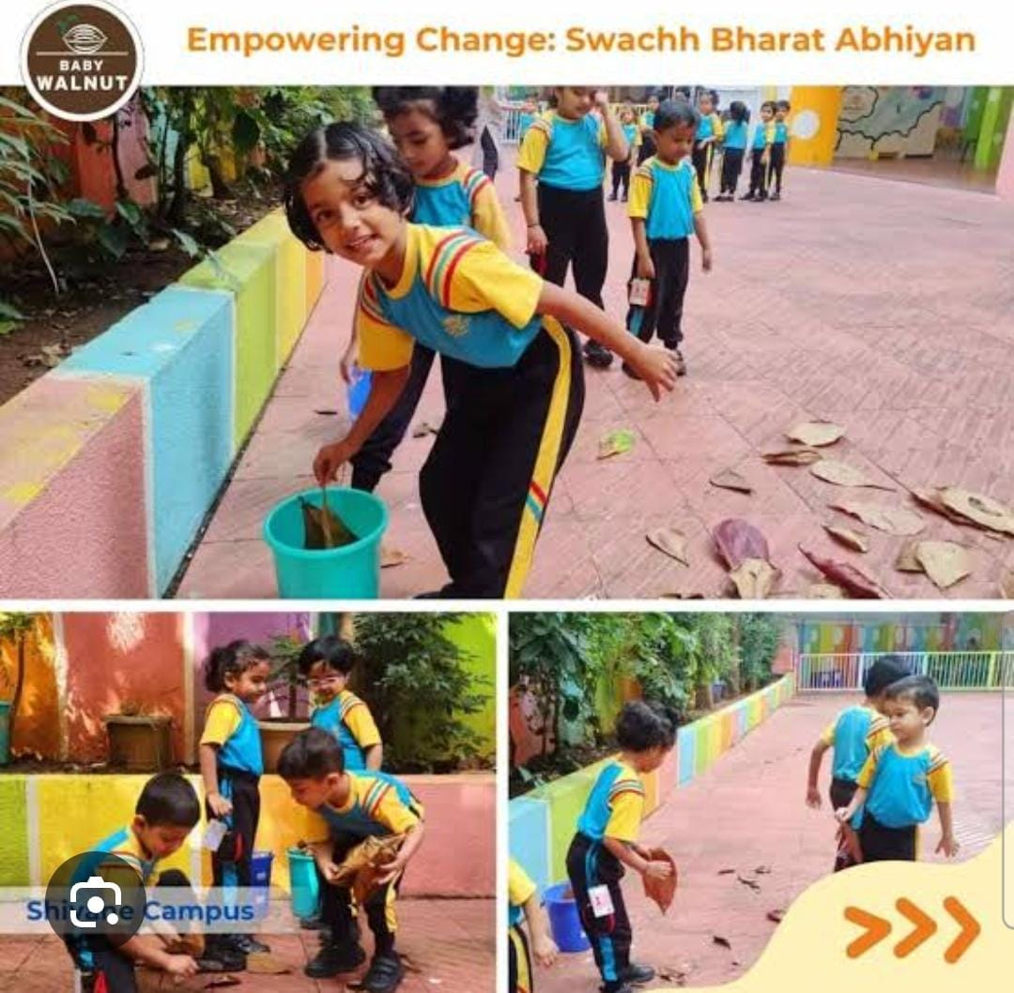

#### 1. **Swachh Vidyalaya Abhiyan (2014)**

* Launched under the larger **Swachh Bharat Abhiyan**, this program aimed to provide separate functional toilets for boys and girls in every government school.
* It set the goal of ensuring that every school has at least one toilet for boys and one for girls.
* Corporates and NGOs were also encouraged to adopt schools under CSR (Corporate Social Responsibility) to construct toilets.

#### 2. **Samagra Shiksha Abhiyan**

* This program supports the provision and maintenance of school infrastructure, including toilets.
* Focuses on inclusive education by ensuring gender-friendly, disabled-friendly, and hygienic sanitation facilities.

#### 3. **Focus on Girls’ Education and Menstrual Hygiene**

* Separate girls’ toilets are prioritized to prevent dropouts among adolescent girls.
* Menstrual hygiene management facilities, including disposal units for sanitary napkins, are being introduced in many schools.

#### 4. **Annual School Sanitation Survey**

* The government conducts periodic surveys and monitoring to check the status of school toilets.
* Schools are graded based on cleanliness and hygiene under Swachh Vidyalaya Puraskar (Clean School Award).

#### 5. **Public-Private Partnerships (PPP)**

* Partnerships with NGOs, corporate houses, and international agencies like UNICEF help fund and monitor school sanitation programs.

**Reference:**

* Hullalli, R., Gudadinni, M. R., & Patil, S. S. (2017). Water sanitation and hygiene in the schools of rural field practice area of Shri B. M. Patil Medical College, Vijayapur. *International Journal Of Community Medicine And Public Health*, *4*(11), 4307–4309. <https://doi.org/10.18203/2394-6040.ijcmph20174849>
* News paper-The Economic Times
* GLAAS, 2012. GLAAS 2012 Report. UN-Water Global Analysis and Assessment of Sanitation and Drinking Water: The challenge of extending and sustaining services. World Health Organization. <http://www.un.org/waterforlifedecade/pdf/glaas_report_2012_eng.pdf>